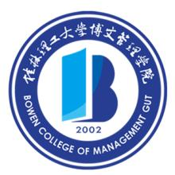

Certificate for Degree of Bachelor

Li Mengwei, female, born on October 7th, 1994, majoring in International Economics and Trade at Bowen College of Management Guilin University of Technology, has successfully accomplished all the courses required and is allowed to graduate.
In accordance with the Regulations on Academic Degrees of the People’s Republic of China, she is awarded the Bachelor of Economics.

President: Wang Jinye
Chairman of Degree Evaluation Committee: Wang Jinye

Bowen College of Management, Guilin University of Technology

Certificate No.: 1364542016000884 Date: June 30th, 2016

(Undergraduate of Regular Higher Education)

